Kaea-Cola Resource Plan, Leveled Schedule, Budget, Change Control Plan, & Project Evaluation

SE 638-001 - Assignment 3 - Fall 2018

Group Members

|  |  |
| --- | --- |
| **K**avya Kumar | kk3283@drexel.edu |
| **A**detayo Olowu | awo24@drexel.edu |
| **E**mily Johnson | ejj42@drexel.edu |
| **A**mjad Alghamadi | aaa492@drexel.edu |

# Who Did What

|  |  |
| --- | --- |
| Members | Responsibilities |
| All members | Discussion, planning, and review Resource Table |
| Amjad Alghamdi | Phase I Change Management - Control Board Total Cost of Ownership; Summary of Business Impact |
| Emily Johnson | Pre-Development Activities; MS Project plan integration Change Management - Flowchart Resource Utilization, Labor Costs, Project Software Costs, ROI Analysis; Summary of Recommendations |
| Kavya Kumar | Phase II Change Management - Tools and Criteria Total Cost of Ownership; Summary of Project Cost and Duration |
| Adetayo Olowu | Phase III; Resource Overlap Review Change Management - Process Overview P&L, Benefits; Summary of Benefits and Risks |

**Table of Contents**

Who Did What 1

Introduction 3

1. Resource Plan and Leveled Plan Schedule 3

Resource Strategies 3

Pre-Development 3

Phase I 3

Phase II 4

Phase III 4

Overall 5

2. Change Management 6

Process Overview 6

Emergency Change Process 6

Makeup of the Change Control Board 6

Tools and Criteria Used for Change Process Control 7

3. Financial Analysis 7

Project Cost Breakdown 7

Total Cost of Ownership 8

Project Benefits 8

Return on Investment Analysis 8

4. Summary and Evaluation 8

Project Impact 8

Summary of Impact on Business Operations 8

Summary of Project Costs and Duration 9

Summary of Benefits and Risks 9

Project Recommendation 9

References 11

Appendix A: Resource Table and Skills 12

# Introduction

Kaea-Cola Inc.is a beverage company that includes 25 business units in different countries including the head office for the African region, which is based in Egypt. We are currently experiencing a number of problems that are impairing our ability to adequately analyze current sales and manage our inventory. We can address many of these problems by improving communication between business units and headquarters, and between business units and our suppliers and customers. Rather than have our employees perform duplicative work re-creating reports based on data that we have already collected elsewhere, we propose an integrated system that will collect data we have already entered and use it to make the work of different business units easier and more responsive to changes in market conditions.

- (Kumar, Johnson, Olowu, & Alghamdi, 2018b).

In our last assignment, we created a project plan for implementing this project across a large, multinational, multilingual company. In this assignment, we are building on that plan and investigating the potential costs.

# 1. Resource Plan and Leveled Plan Schedule

Based on our work in Assignment 2, we scheduled resources for the tasks in our project plan using the resource table shown in Appendix A: Resource Table and Skills. The leveled project plan schedule is included in the file Grp2-A3-SE638-Fall2018-LeveledProjectPlan.mpp.

## Resource Strategies

### Pre-Development

In pre-development, we use the services of a consultant requirements analyst and an additional business analyst that we do not use in the other sections. Together with the systems analyst, the documentation specialist, and the project manager, these analysts form a seven-person pre-development team. In order to minimize the amount of pre-development time necessary, we have this team split up to observe operations in different business units and different locations, conducting five separate observation groups. There are a couple of meetings to make sure that everyone has a chance to check in, compare what they are seeing, and identify questions that they might ask.

After the observations, we will conduct application design workshops for different units; again, these are designed to run in parallel so that we can complete them in a limited time frame; we then have the feasibility studies and our project planning phase, the last of which takes more time because it requires the dedicated skills of our project manager.

### Phase I

In Phase I, after the pre-development activities, we will start creating the initial system and its requirements and components. The resources plan was implemented based on the existing tasks. Most of the resources will deal and interact with the system. We have the project manager who will be involved in most of the tasks in phase I to monitor and take all appropriate decisions. The other resources will be involved in different tasks depends on their specialty. Some of these resources will collaborate in one task. For instance, implementing and testing the database structure when developing the Interface and Security for Supplier Web UI, we need to involve the database administrator and the software tester to do this task. I want to mention that the consultant network specialist will be involved just in Phase I by installing hardware server and testing the network connection.

In the first phase we distributed the tasks to the sources, there were some overlaps in work, but we divided the work between sources to avoid overlaps and to avoid having large gaps without doing anything in the periods between the first task and the second task for the source. When comparing the end date, in the beginning, I assigned more than two sources for most of the tasks; then I realized that I need to specify the sources for each task specifically to reduce the amount of time, so the time was reduced. Unfortunately, some tasks required more than two resources to be assigned, so there was no choice to ignore or override assigning more than two resources.

### Phase II

In phase 2, the majority of the tasks have only one resource allocated to them. This is to ensure complete utilization of the resources. For collaborative tasks, more than one resource is allocated. For example, in the task Phase II Kickoff meeting where project manager, business analyst, programmers, database administrators and system analyst are involved. Similarly, in Stagegate review at the end of phase II, project manager, business analyst and system analyst are involved.

With intent to streamline the project timeline and reduce the lag time, certain tasks are overlapped. In the team planner snapshot below, while developing the advanced integrated business management system, following tasks are performed in parallel. During the development of marketing and development server app of ‘Product code database and lookup subsystem’, the task of software designing and coding is assigned to programmer 1. Also, the implementation and testing database structures task of Sales and Market database of ‘Operations Management and Reporting subsystem’ is scheduled and Database Analyst is the resource that is allocated. The starting date of both the task coincide.

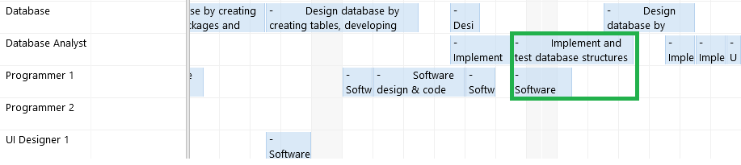

Increase in the resource utilization and to cut down the additional costs by estimating the costs in accordance with the market value are the factors to be considered for project budget. In phase 2, Programmers 1 and 2 are utilized to maximum extent to eliminate the need to hire another programmer.

### Phase III

Phase 3 implementation commences with a review of phase 2 activities and lessons learned, which requires the input and expertise of the core team (BA, PM, Programmer, etc). The system implementation components have a mix of core and junior/secondary team members to ensure reduced learning curve, transfer of knowledge, efficiency and effectiveness in the process. Other project delivery activities such as training, documentation, project closure etc. employs the knowledge and skill of the project manager and documentation specialist.

### Overall

Across all of the phases, we noted that leveling the plan increased the duration of the project; this makes sense, because leveling makes sure that we don't have a resource trying to work at more than 100% capacity at any time, and so it moves tasks further down the timeline as needed.

Originally, we had three more resources in our resource plan; we weren't sure how many we would need, but wanted to have a single group of resources that all planners would use. After integrating the different phases into a single project, we produced a leveled version, then ran a resource utilization analysis to see if there were resources that we could cut out. We readily identified three (a programmer, a UI designer, and a software tester) that we could remove without having to change much. We also limited the use of our Business Analyst 2 to the pre-development phase. These changes saved us over one million dollars in estimated Resource Utilization costs immediately.

We then aggressively revised our task predecessors to remove any artificial delays; if we reasonably could start work on a component after a particular task, we set the predecessors accordingly. We also revised our overlap between phases so that rather than starting a phase after waiting for user feedback, we now started a phase immediately after the documentation and acceptance test for the previous phase was complete. (In some cases, we still waited until after feedback to start work on particular subcomponents, but each phase typically starts with system management and security work that is unlikely to be heavily affected by the results of our user evaluations.) We also revised the predecessors so that many subcomponents could be started in parallel (although we might wait for a particular part to be designed before designing and coding the next). These changes saved an additional three million dollars; although we saved an earlier revision so that we could roll back, all of the phase project managers agreed that this was so drastic an improvement that they could see the benefit of the changes.

After that, to further improve our budget, we reviewed the project plan to limit cases where we had assigned two or more resources to the same task, evaluating whether a task really needed multiple resources. This lowered our overall utilization rate, but still saved us about three hundred thousand dollars, in part because it cut nearly a month off of the leveled project plan schedule.

(The reports that led us to these conclusions can be seen in the included Excel file Grp2-A3-SE638-Fall18-AppendixB-ResourceUtilizationReview.xlsx.)

We tried to do some additional manual reallocation, but found that it did not always produce significant benefits, and sometimes actually lengthened the time it took to perform the project (which was the opposite of what we expected). This left us with some significant utilization gaps; ideally, we would further consolidate our resources and then do some additional reallocation of work to make sure that the work is evenly spread across phases. The scope of the project made this somewhat difficult, however, as is the fact that if we allow certain tasks to be done in parallel, the tasks that follow will also likely be ready in parallel. (Having tasks with more variation in duration might help, as could further dividing tasks.)

# 2. Change Management

## Process Overview

A change management plan would be developed as part of the project planning phase, which will cover the change control process, creation of a change control board (CCB), approval levels, tools and templates to track and monitor changes and emergency change processes. Changes shall be categorized in terms of preventive action, corrective action and rework, which includes continuous improvement to software components, bug fixing, customer enhancements, etc. Changes shall also be assigned level of impact (low, mid, high) and this would be determined by the CCB. All changes shall be reviewed and approved/rejected by the CCB.

The CCB shall adopt an **integrated change control** process, which would evaluate the impact of a change on the system and other competing project constraints (risk, quality, schedule, budget, etc.). Approved changes by the CCB shall be assigned an owner, manager and implementer.

### Emergency Change Process

Emergency changes shall be limited to incidents (server outage, security breach, etc.) and any other factors that may affect the successful completion of the project within the defined constraints. The emergency process would be activated only when an incident, pressing business requirement or operational issue cannot be efficiently handled by the normal change management process, due to time and approval constraints.

For the purpose of emergency changes, the project manager and project sponsor shall have authority to approve the implementation of such changes to restore normalcy. However, the normal change management process would take place post-implementation to address any gaps or process improvement opportunities.

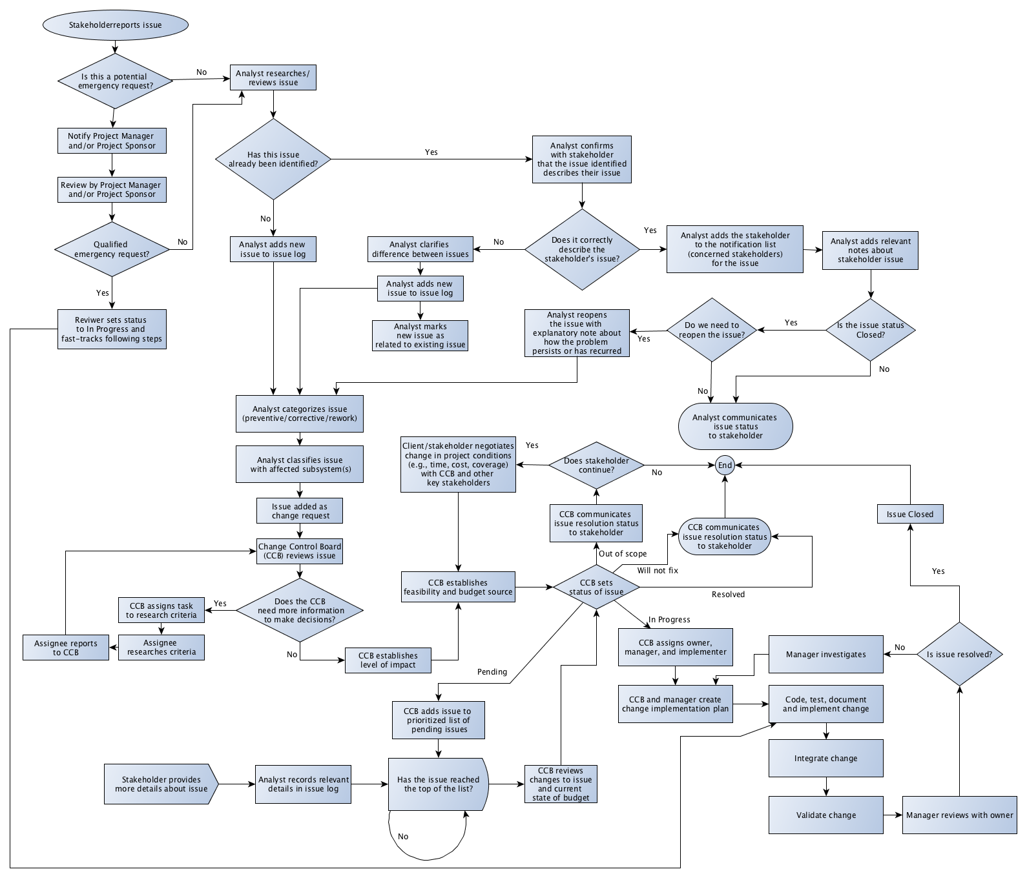

Figure 1 - Change Control Flowchart

## Makeup of the Change Control Board

The CCB is a change control board consisting of experts and technical staff who have the experience and power to make decisions about the project. They will review and prioritize the change requests related to a project, then make decisions on the changes to the software project, and their choice of whether to approve or deny proposed changes will affect how the project proceeds.

In this project, the change control board (CCB) includes:

* The **project manager** who has experience in managing and controlling the project.  
  The project manager will be responsible for all project management procedures such as scope management, issues management, risk management, etc.
* The **project sponsor** who represent various functions within the organization and has ultimate authority over the project.
* A **business analyst** who is responsible for analyzing users’ point of view to document what business needs and document the requirements.
* A **system analyst** who will specializes in analyzing, designing and implementing the information system. The system analyst will be responsible for looking at the project from technical user's point of view.
* The **database administrator**, who has experience setting up the database and with analyzing or designing databases.

## Tools and Criteria Used for Change Process Control

**Project Impact statement**: Evaluating the impact of the change request on the project plan. This impact is analyzed in accordance with time frame, resources or budget.

**Change Request Log**: A dynamic document is maintained that includes all the suggested scope of change, reason for why the change is required, the time frame that is essential to incorporate these changes with the existing system, estimated cost and the additional factors such as previous changes. This document is updated as and when the change requests are accepted. It also includes potential benefits and adverse effects to each stakeholder and to factors like process and technology.

We will also use **variance charts** including planned budget, actual budget, and the difference between the two, to analyze the if we need additional resources.

Additionally, the change control board evaluates the impact of changes on the project by considering the following questions:

* Does the proposed change add or modify the business requirements?
* Does incorporating this change require increase in the budget estimated?
* Does this change require extension of time frame?
* Is this change necessary for overall success of the project?
* Is it possible to integrate the change proposed with the existing system without significant variation in the project?

# 3. Financial Analysis

We created a financial analysis report in the included Excel file Grp2-A3-SE638-Fall18-WBS-ROI-Estimate.xlsx; the sections below refer to that file. We did not include the project estimates from Assignment 2 as some tasks have changed slightly (although the estimates for the majority of the tasks have not). To avoid confusion, we have instead used the durations from the project plan schedule.

## Project Cost Breakdown

The project cost breakdown was based on the final leveled project plan. We used the resource plan and costs developed and researched in Assignment 2 (Kumar, Johnson, Olowu, & Alghamdi, 2018c) to get daily costs for each resource. We then took the WBS, durations, and resource assignments from the project plan and used them to calculate an estimated cost for each task (and consequently, rollup costs for each activity, component, and phase). The top two levels of the WBS were extracted for use in the project cost breakdown.

Meanwhile, we also ran a Resource Utilization breakdown based on the resources we had assigned in project, their daily costs, and their start and end dates. For the final revision of our project, our resource utilization was not particularly high (although we think that we will make additional use of these resources in our change management process and through cross-training opportunities).

Rather than give an artificially low labor estimate based on the per-task costs from the WBS, we instead chose to incorporate the entire estimated labor cost for the project. We knew there was additional overhead involved as well (including sunk costs in work spaces and equipment), so we calculated the overhead (at a 45% rate) based on the per-task costs, and added it to the total estimated labor cost. We then compared this total to the cost estimate that was gathered via the per-task analysis, and used that comparison to get a total percentage rate (160%) that could be applied to the project cost breakdown to cover the additional labor costs and overhead.

We feel that this is a better estimate of our true project costs than we could get based on the WBS costs alone.

## Total Cost of Ownership

Our total cost of ownership includes sections for the costs of implementing the new systems, business process changes, and operation expenses related to the new systems. Notes are provided for each section.

## Project Benefits

To develop our project benefits analysis, we needed some baseline cost and sales estimates to start with. Since we were looking for costs for a small beverage company, we used the 2014 Annual Report of the National Beverage Corporation (who produce brands like Shasta, LaCroix, and Faygo). The company has just over a thousand employees and in 2014 they had 2.9% of the United States market share in carbonated soft drinks (Beverage Digest, n.d.). Since we expected our business to be somewhat smaller, rather than use their raw numbers, we scaled our budget to a fraction of theirs (2.5%) for an annual sales total of about $15 million rather than $600 million. This produced the basis for our Profit and Loss sheet; we used the averages over four years to get a typical number.

We based our project benefits on the revenues and profits from the Profit and Loss Sheet. Each row contains a note about the expected benefits (sourced from our Project Overview Statement in Assignment 1 (Kumar, Johnson, Olowu, & Alghamdi, 2018b)) and about the calculations used.

## Return on Investment Analysis

To calculate our return on investment analysis, we laid out the expected benefits over each of the five years following the implementation of the new system, and then laid out the project costs and the total costs of ownership for each of those five years. For each year, we took the difference between the benefits and the costs as our total cashflow. The cumulative cashflow balance shows the total cashflow amount since the start of year 0 (implementation) at the end of any given year.

The ROI after 5 years is the cumulative cashflow amount at the end of the five-year period. To get the ratio, we divided the ROI by the total system costs (the costs of the project software and the total cost of ownership over five years).

# 4. Summary and Evaluation

## Project Impact

### Summary of Impact on Business Operations

To avoid many of the problems that Kaea-Cola is now facing, we will follow and implement a set of ways that will change Kaea-Cola's business operations. We are going to enhance and improve the communications between the units inside the company to be more effective and efficient, and also enhance the relations between the company units and our suppliers and consumers. This will help us avoid problems that prevent us performing tasks well. Instead of doing duplicative work in doing reports, we are going to instantiate a new system to collect data that we entered to make the work of the units to be more accessible and responsive than before. When we deliver our product to a particular region, we will analyze our sales in that region to avoid having shortages nor oversupplies of any product, so it will help us to specify market opportunities more quickly. However, we will forecast the demand based on current and past sales, and market trends. Also, we are going to standardize our product codes to encode flavor, dilution ratio, form factor, and an amount in a package, such that any sales or delivery report automatically includes this information.

### Summary of Project Costs and Duration

#### Costs

The project software cost including development and component cost is around $7,969,778. The total cost of ownership over 5 years is $2,125,731. This leads to an overall cost estimate for the entire project of $10,095,509.

#### Duration

The duration to develop this project is around 2.5 years starting from January 2019 to July 2021.

The Pre-development activity phase takes around 44 days, while phase 1 takes about 229 days. The reason is because in pre development phase, much of the analysis and planning strategies are carried out but in phase 1, the subsystems are developed with basic functionalities. Advanced functionalities of the subsystems developed in phase 1 and server and client applications are added in phase 2 which takes around 167 days. Phase 3 involves incorporating the change management and system integration activities that can be achieved in 331 days.

### Summary of Benefits and Risks

The major benefits to be delivered by the project includes a standardization of business processes across all locations, more effective communication and reporting processes and procedures. As a result, we expect greater efficiency levels, shorter turnaround times, increase in revenue and significant cost savings from cutting down on wastage and losses from currency variations.

The major risks associated with this implementation include delay or failure to complete the project due to the scope, timeline and complexity of the project. The project takes over 2 years to deliver all phases, this may have an impact on user adoption and system relevance after such a long period of time.

## Project Recommendation

Although this project represents a major undertaking for this company and will require considerable investment of time and money, we consider this project essential to the future success of the company and our hopes for expansion. When we did a cost-benefit analysis, we found that our estimated benefits would easily put us in the black in the next year, and we would have a positive return on investment in two years. Over the course of five years, we expected that the cumulative benefits would provide a significant ROI of over $29 million, which far outstrips the $10 million in anticipated total costs over five years.

Not only is this project important to the future growth of the company through making us more agile and more prepared to compete with our rivals in the modern marketplace, but the return on investment should help provide us with additional revenue that we need to grow our business. We recommend the implementation of this project.

# References

Akabawi, S. & Hodeeb, H. (2011). Implementing business intelligence in the dynamic beverages sales and distribution environment. In El-Khazindar Business Research and Case Center (ed.), *Cases on business and management in the MENA region: New trends and opportunities* (156-176). Hershey, PA: Business Science Reference. Retrieved on September 28, 2018 from: <https://learn.dcollege.net/bbcswebdav/pid-6892205-dt-content-rid-52277103_1/xid-52277103_1>

Beverage Digest. (n.d.). Soft drink market share by company in the U.S. from 2004 to 2015*. In *Statista - The Statistics Portal*. Retrieved November 11, 2018, from <https://www.statista.com/statistics/225464/market-share-of-leading-soft-drink-companies-in-the-us-since-2004/>.

*Case 1: Beverage supplier process flows* (n.d.) Retrieved on September 28, 2018 from: <https://learn.dcollege.net/bbcswebdav/pid-6892205-dt-content-rid-52277101_1/xid-52277101_1>

Kumar, K., Olowu, A., Johnson, E., & Alghamdi, A. (2018a, September 30). *INFO 638 project proposal* [class assignment].

Kumar, K., Olowu, A., Johnson, E., & Alghamdi, A. (2018b, October 14). *Kaea-Cola Project Scope and Proposal* [class assignment].

Kumar, K., Olowu, A., Johnson, E., & Alghamdi, A. (2018c, October 28). *Kaea-Cola Project Estimates, Resource Plan, and Working Schedule* [class assignment].

Glassdoor. (n.d.). Glassdoor Job Search | Find the job that fits your life. Retrieved October 28, 2018, from https://www.glassdoor.com/index.htm

National Beverage Corporation. (2014). *National Beverage Corp.* *2014 Annual Report* [Annual Report]. Retrieved November 11, 2018 from <http://ir.nationalbeverage.com/static-files/f639411d-7844-47b2-aae1-85ec0aa4a9da>

# Appendix A: Resource Table and Skills

|  |  |  |  |  |  |
| --- | --- | --- | --- | --- | --- |
| Resource Name | Initials | Std. Rate | Ovt. Rate | Cost/Use | Skills |
| Business Analyst 1 | BA1 | $154.40/hr | $154.40/hr | $0.00 | Requirements analysis; specializes in business user POV |
| Business Analyst 2 | BA2 | $154.40/hr | $154.40/hr | $0.00 | Requirements analysis; specializes in business user POV |
| System Analyst | SA1 | $166.50/hr | $166.50/hr | $0.00 | Requirements analysis; more technical POV |
| Project Manager | PM1 | $222.30/hr | $222.30/hr | $0.00 | Jack-of-all-trades |
| Documentation Specialist | DS1 | $132.77/hr | $132.77/hr | $0.00 | Technical writer; trainer; user documentation (as opposed to programming documentation, but can also do that) |
| Consultant Requirements Analyst | CRA1 | $151.70/hr | $0.00/hr | $606.80 | Requirements analysis **Note: Only available in first part of Pre-Development activities** |
| Consultant Network Specialist | CNS1 | $138.00/hr | $0.00/hr | $552.00 | Server and networking setup **Note: Only available in Phase 1** |
| Database Administrator | DBA1 | $44.79/hr | $0.00/hr | $0.00 | Database setup; also does database analysis and design; database programming |
| Software Test Engineer | STE1 | $44.98/hr | $0.00/hr | $0.00 | Testing design and software testing |
| Software Tester 1 | ST1 | $33.60/hr | $50.40/hr | $0.00 | Software testing |
| Software Tester 2 | ST2 | $33.60/hr | $50.40/hr | $0.00 | Software testing |
| Programmer 1 | PA1 | $163.38/hr | $163.38/hr | $0.00 | Design and code |
| Programmer 2 | PA2 | $163.38/hr | $163.38/hr | $0.00 | Design and code |
| Programmer 3 | PA3 | $163.38/hr | $163.38/hr | $0.00 | Design and code |
| UI Designer 1 | UI1 | $148.88/hr | $148.88/hr | $0.00 | User interface designer; design and code, client-side apps in particular |
| UI Designer 2 | UI2 | $148.88/hr | $148.88/hr | $0.00 | User interface designer; design and code, client-side apps in particular |
| Database Analyst 1 | DA1 | $144.80/hr | $144.80/hr | $0.00 | Database analysis and design; database programming |